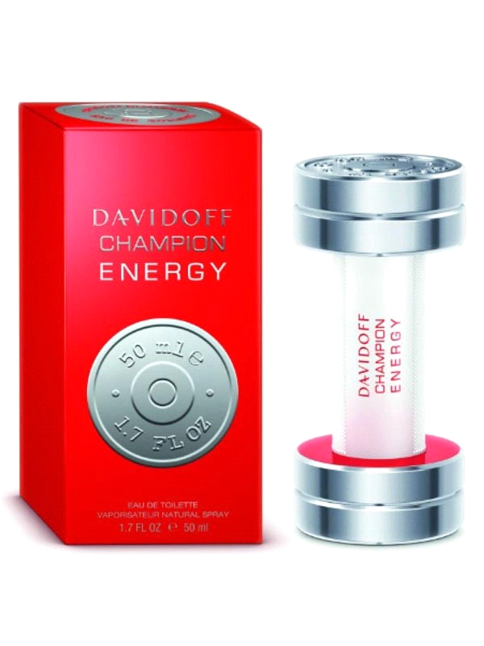

An aromatic spicy fragrance for men Fresh, zesty & invigorating Top notes of bergamot & grapefruit Heart notes of galbanum & spices Base notes of cedar & oak moss Launched in 2011 Suitable for sports & causal wear.

Brand Name: Davidoff

Product Code: SH-DF-4154

Quantity (ML) 90 ML

Made: Imported

Gender: Male

Price: RS.3,499/-